**What is git?**

|  |
| --- |
| 1. It is a version control system |

**3 types of version control systems**

1. **Local Version Control:** Here we store the application in our local system. If the system won’t work or hard disk is not working, the total application will be gone. We can’t get it back.
2. **CVCS(Centralized Version Control System):**Centralized version control systems are based on the idea that there is a single “central” copy of your project somewhere (probably on a server), and programmers will “commit” their changes to this central copy.

“Committing” a change simply means recording the change in the central system. Other programmers can then see this change. They can also pull down the change, and the version control tool will automatically update the contents of any files that were changed.

Some of the most common centralized version control systems you may have heard of or used are, Subversion (or SVN) and Perforce.

**Main benefits:**

* Centralized systems are typically easier to understand and use
* You can grant access level control on directory level
* performs better with binary files

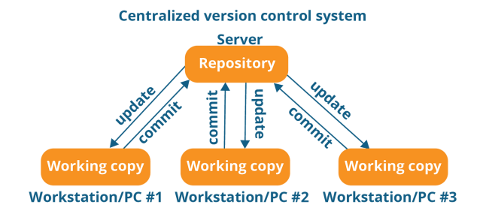

**Distribute Version Control System:**

In distributed version control, every developer “clones” a copy of a repository and has the full history of the project on their own hard drive. This copy (or “clone”) has all of the metadata of the original.

This method may sound wasteful, but in practice, it’s not a problem. Most programming projects consist mostly of plain text files (and maybe a few images), and disk space is so cheap that storing many copies of a file doesn’t create a noticeable dent in a hard drive’s free space. Modern systems also compress the files to use even less space.

The act of getting new changes from a repository is usually called “pulling,” and the act of moving your own changes to a repository is called “pushing”. One common misconception about distributed version control systems is that there cannot be a central project repository. This is simply not true — in most cases you have one central server which is an authoritative one. The most popular of these are Git and Mercurial.

## Main benefits:

* Performance of distributed systems is better
* Branching and merging is much easier
* With a distributed system, you don’t need to be connected to the network all the time (complete code repository is stored locally on PC)

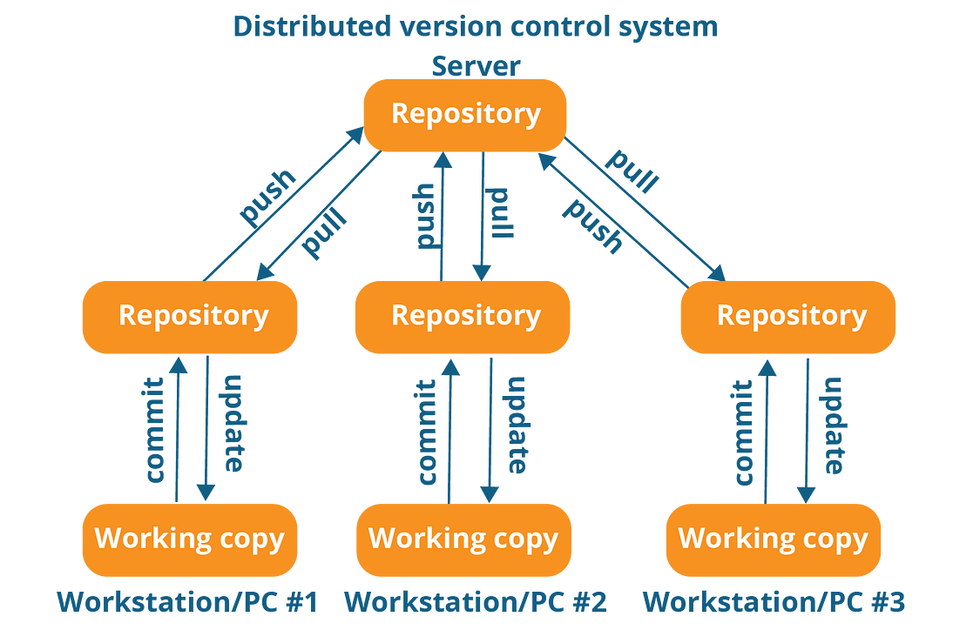

**Git installation**

**Download the git**

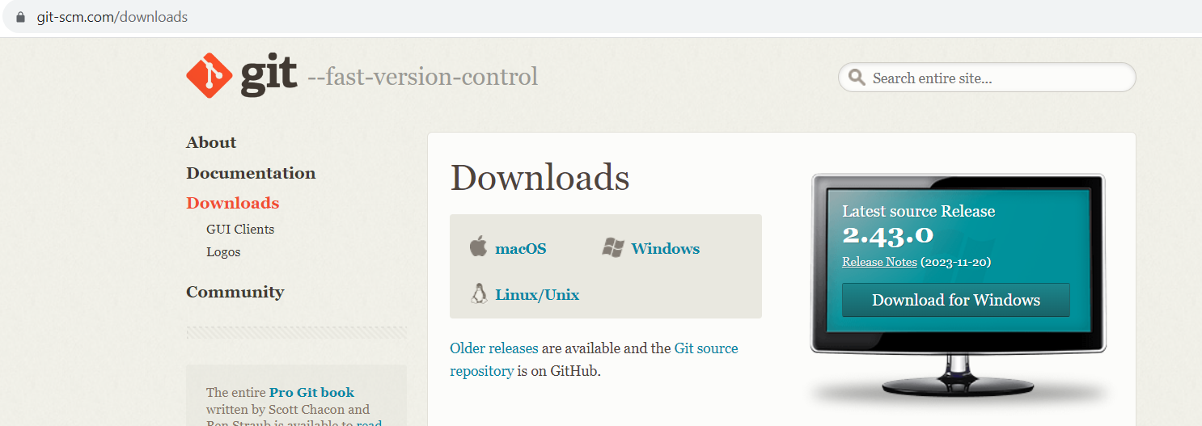

**Install it**

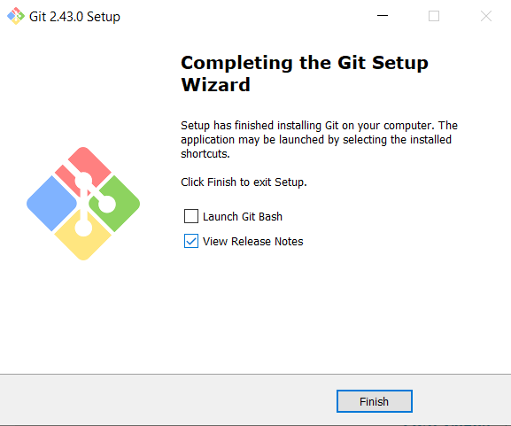

**Done**

|  |
| --- |
| Now we got the git setup. |

**Verify whether the git was installed correctly or not**

|  |
| --- |
| 1. Open the command prompt or power shell |

**When you work with git you need your own identity right? So How we can set it?**

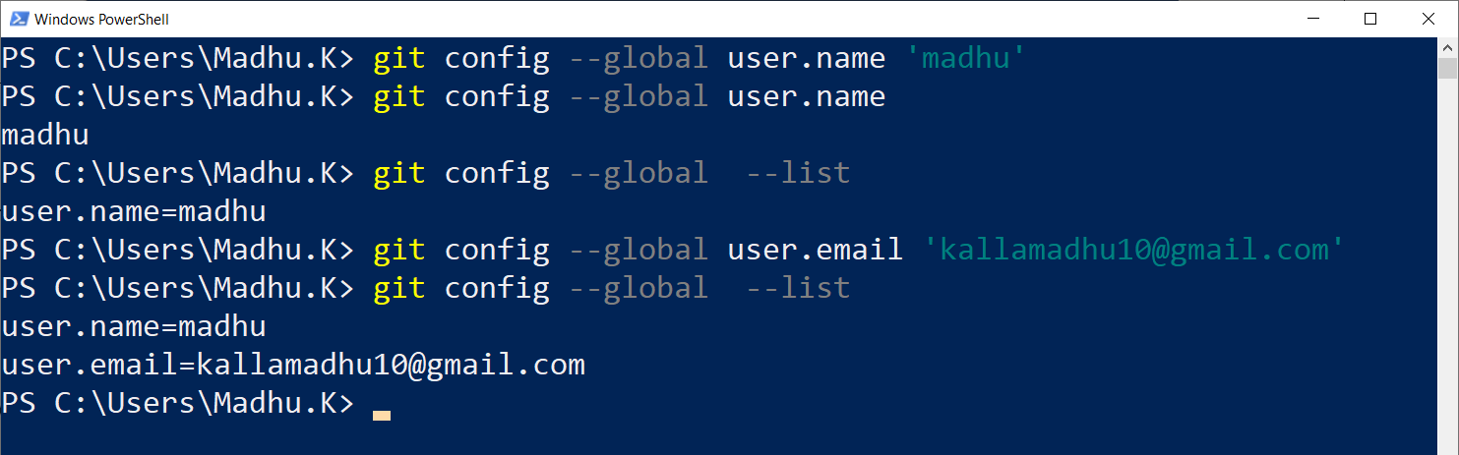

**To work with git better you need to have an editor( or IDE).**

|  |
| --- |
| I have installed VS-Code  Create a folder and open it in VS-Code    Now open the terminal    Terminal |

**What is working directory**

|  |
| --- |
| Here First project is working directory |

**Staging Area**

|  |
| --- |
| 1. It is a place where git works 2. Whatever you are doing you have to push that into staging area. |

**Commit history**

|  |
| --- |
| Every time you commit a new version will be created in git. It helps us to go back if you want. |

**Local Repository**

|  |
| --- |
| If you give the below command then it will give the status. If no git repository exists we will get error like below    Command to create local repository is(to do that initialize the git see the below command)    Empty git repository is created but it is a hidden folder you can’t see directloy in First Project  The staging area and commit history will be placed within the this folder called “.git”  **Note:**  If you are creating a file in working directory! Remember that, that file is part of working directory it is not part of git okay.  **Run git status command**  Now run the git status command. And you can see a new branch is created with a name called master. |

**Creating a new branch with name main**

|  |
| --- |
| Better don’t work on master branch so we will create a new branch with name (our wish) main.  Remove the master branch and create a new branch using below command      Now run the git status and you can find the main branch |

**How to move a file written in working directory to staging area**

1. Creating file in working directory(see the below image)

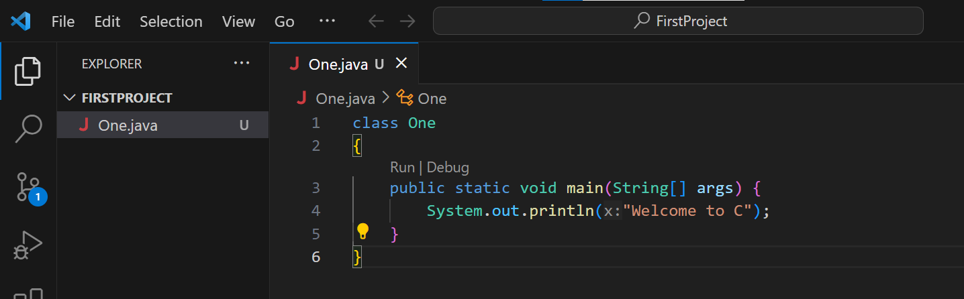

1. After creating file check the git status like below, then it will show the new file as untracked files list

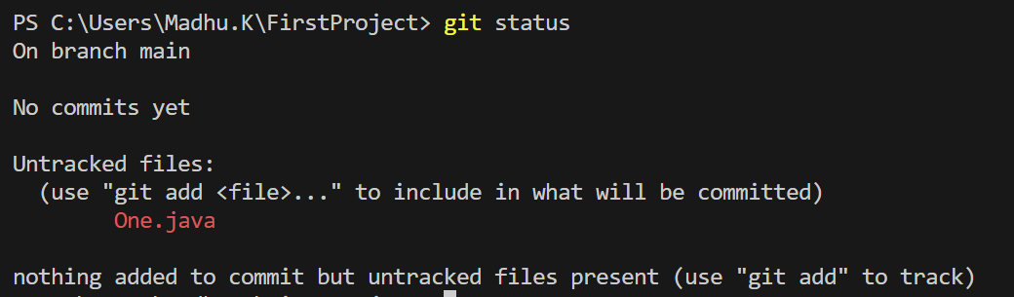

How to add One.java file from working directory to Staging area?

|  |
| --- |
| Use the git add <file-name> command to do that see the below image    One.java file is added to staging area.  Run the status |

Restore the files existed in local repository to working folder

|  |
| --- |
| 1. git restore ThisDemo2.java 2. git restore ThisDemo.java |

To restore into working directory from staging area write the below command

|  |
| --- |
|  |

Restore all files from staging area to working directory

|  |
| --- |
|  |

How to see the no.of commits done till now?

|  |
| --- |
| This below command |

How we can commit?

|  |
| --- |
| If you Modified file then you have to add file to staging and then you can commit    If you see the status after coming it shows nothing to commit. |

When the file will be tracked by git?

|  |
| --- |
| Note: Once commit is done you can say that the file is tracked by a git. |

What is Check sum?

|  |
| --- |
| A checksum is a value derived from the digital data of a file or set of data used to verify the integrity of the data.  It is a way of ensuring that the data has not been corrupted or tampered during transmission or storage.  Here's a simple explanation of how it works:  Generating a Checksum:  A checksum algorithm processes the data, producing a fixed-size string of characters (the checksum) based on the content of the data.  This process is designed in such a way that even a small change in the data will result in a significantly different checksum.  Verifying the Data:  The sender generates the checksum for the original data and sends both the data and the checksum to the receiver.  The receiver then recalculates the checksum based on the received data.  If the recalculated checksum matches the checksum received from the sender, it indicates that the data is likely intact.  Checksums are commonly used in computer science, telecommunications, and networking to detect errors in data transmission or storage. They provide a quick way to verify data integrity without having to compare the entire content of the data. If the checksums match, it suggests that the data is likely free from corruption. If they don't match, it signals a potential issue with the data.   1. When you commit a file or project you can see at least 7 characters that is called as checksum but it is total 40 characters long but it displays only 7 characters. 2. Every time when you commit a file in git, it will check any modifications are needed or not based on the new file checksum value and old checksum value if both checksum values are same which means no commits needed otherwise commit is needed. |

If you want to see the commit history run the below command?

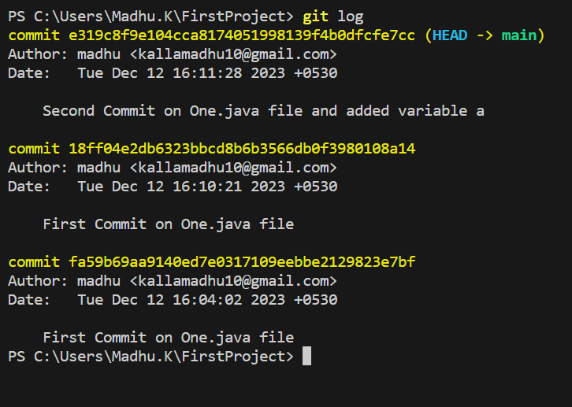

Can we commit a file from working directory to commit without involving in staging area?

|  |
| --- |
| Yes we do, -a we have to use    See the log |

Can we find out what is the new code added to the file?

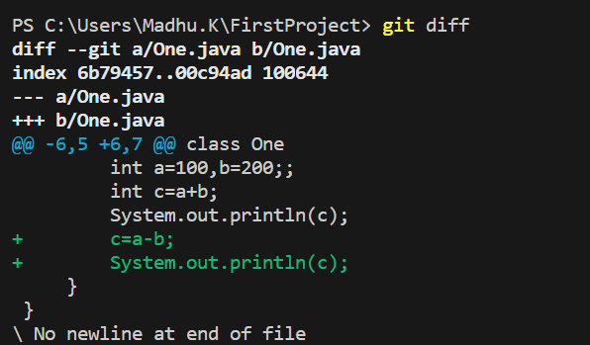

Now it is showing the difference right? Now I am moving file from working folder to staging area? But can we move the file directly from working folder to commit area without staging.



I have modified the file and moving to staging after modification

One.java

import java.util.Scanner;

class One

{

    public static void main(String[] args)

    {

        Scanner scan=new Scanner(System.in);

        int a=100,b=200;;

        int c=a+b;

        System.out.println(c);

        c=a-b;

        System.out.println(c);

    }

}

Adding this file to staging and checking any difference is there

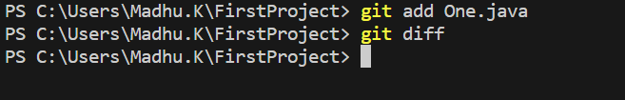

The file which is in Working folder and staging file both are same right! So that is the reason why we didn’t get any difference.

Can we check the file in staging area with the file in commit (git)?

|  |
| --- |
| Yes, but we have to use git diff --staged |

Moving the file from staging to git (local)?

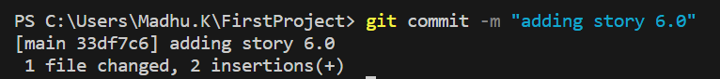

I have created 2 files and see the status

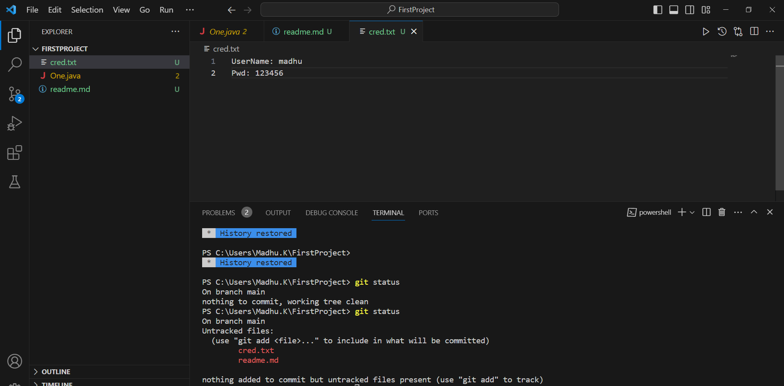

Status saying that 2 untracked files are there, So now I wanted to move all those files into

git.

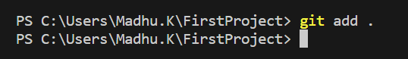

Git status

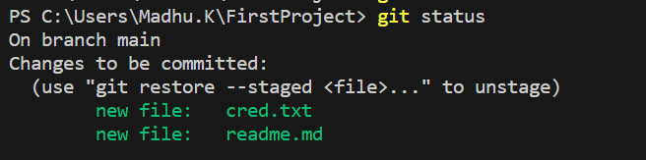

I did modification in One.java and added all the files at a time and see the status

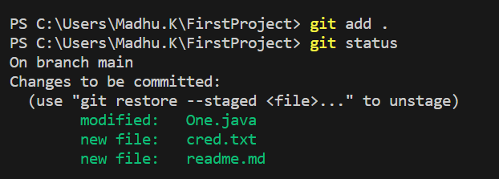

Removing a file from the git?



Git status

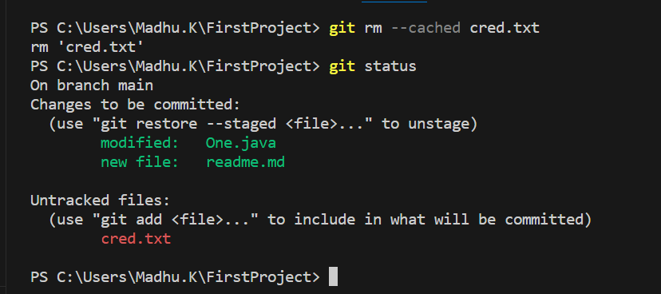

Deleted cred file from vs code also and after that I committed the remaining files to git

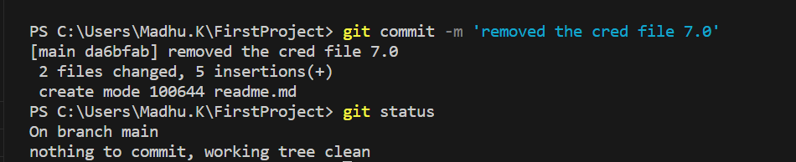

**Remote repository**

What if you want to collaborate with every one let us say you are working in a team every one working on their allotted tasks and you all have to commit all work in a common repository in that situation we need remote repository.

We can use github or git lab or bitbucket etc... as remote repositories. At present we are using github.

1. Create account first
2. Login into that account

This is my github account

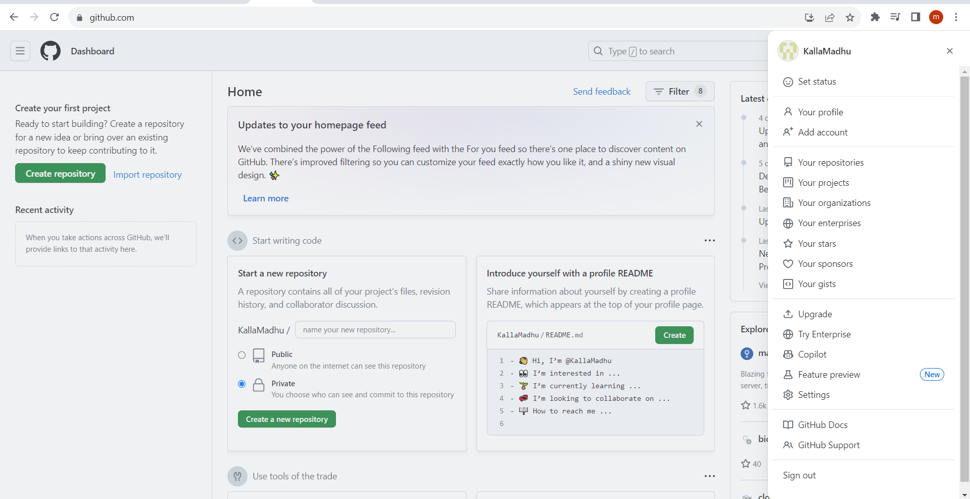

How to use github?

|  |
| --- |
| 1. Many public repositories will be there 2. We can search for an application or logic or program 3. We can download the zip file or we can clone it   Copy the URL like below    Clone it using the url like below |

Creating a new repository in GitHub

1. Click on new repository

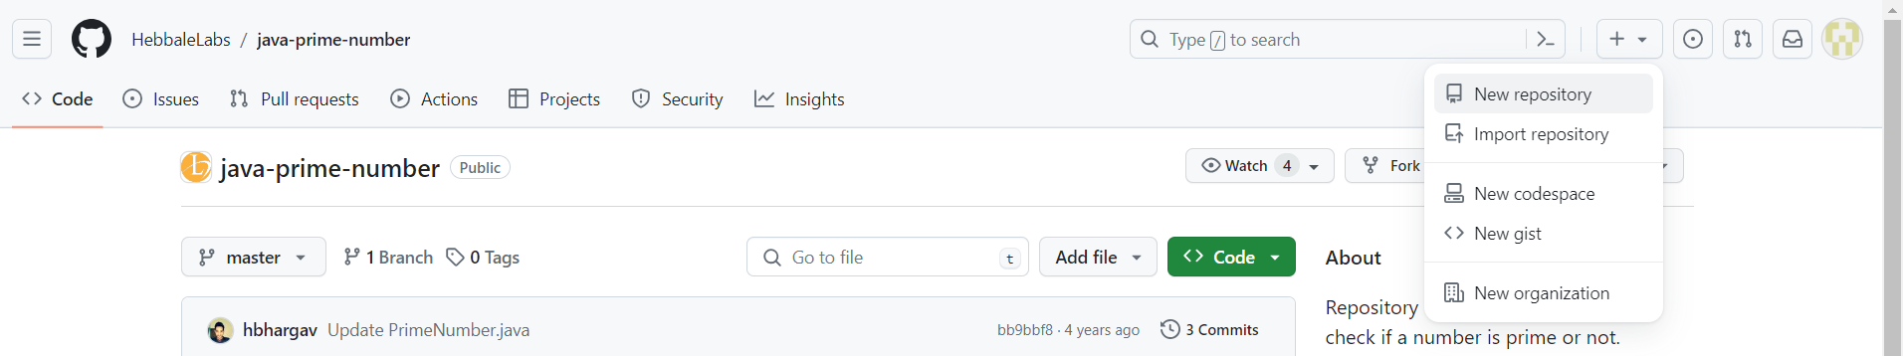

1. I have created a new repository called ‘git-practice1’

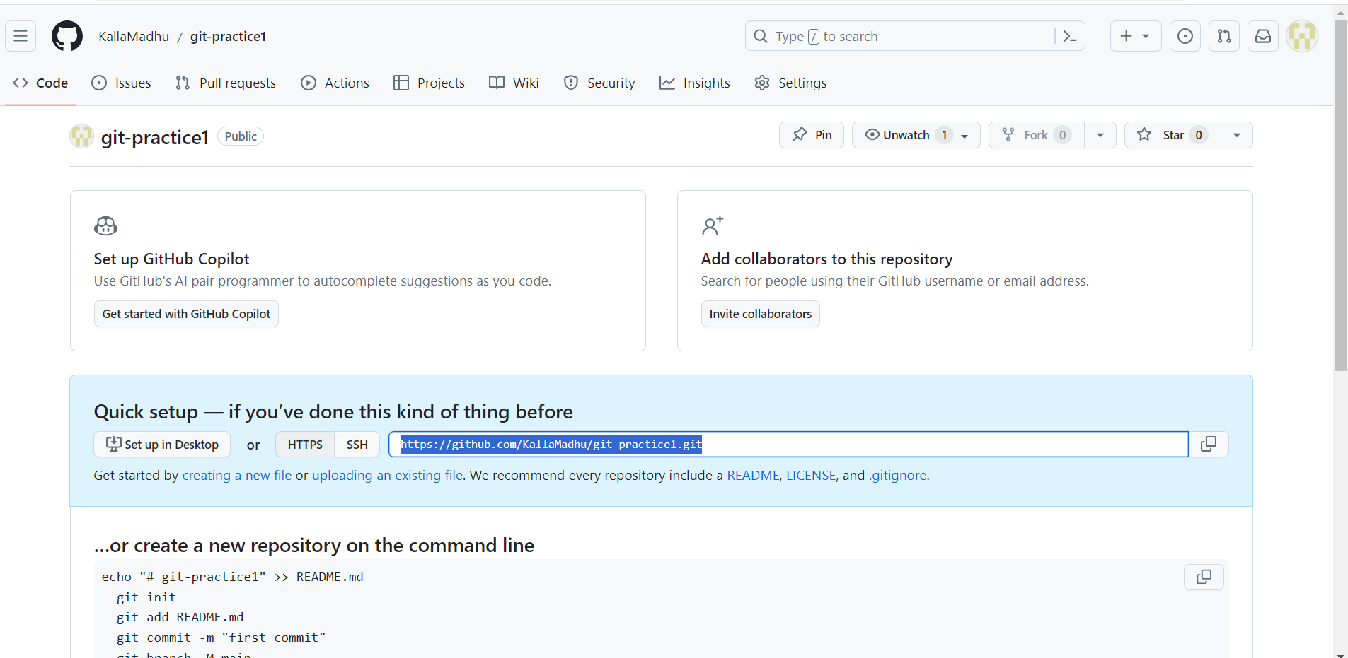

1. Creating a local repository
2. First create a folder git-practice1 and open it in vs code
3. Create readme.md file and add

Below code

#git-practice1

1. Create local repository using git init command

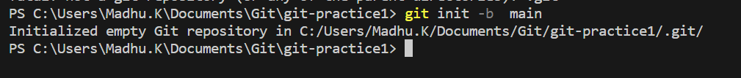

1. Status

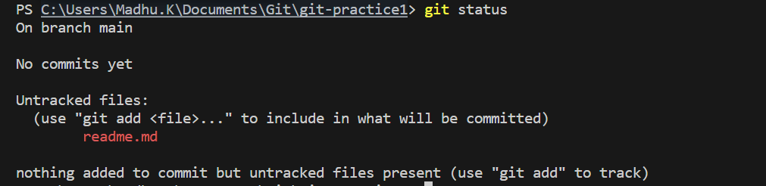

1. Moved the readme.md file into staging area

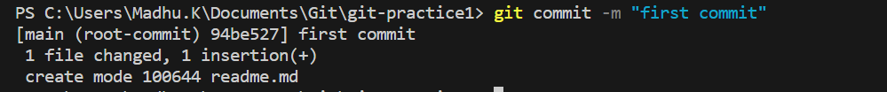

1. To upload you project or file into remote repository you have to setup the SSH. You need to generate ssh only one time for one machine. Command is

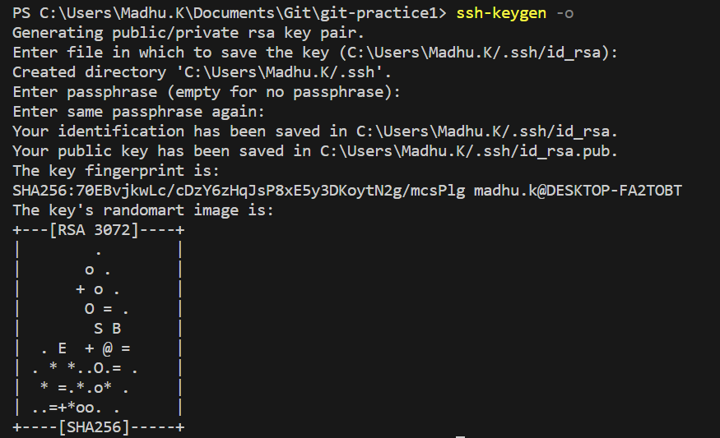

Ssh files are created in this path in “C:\Users\Madhu.K\.ssh”

1. Read the key

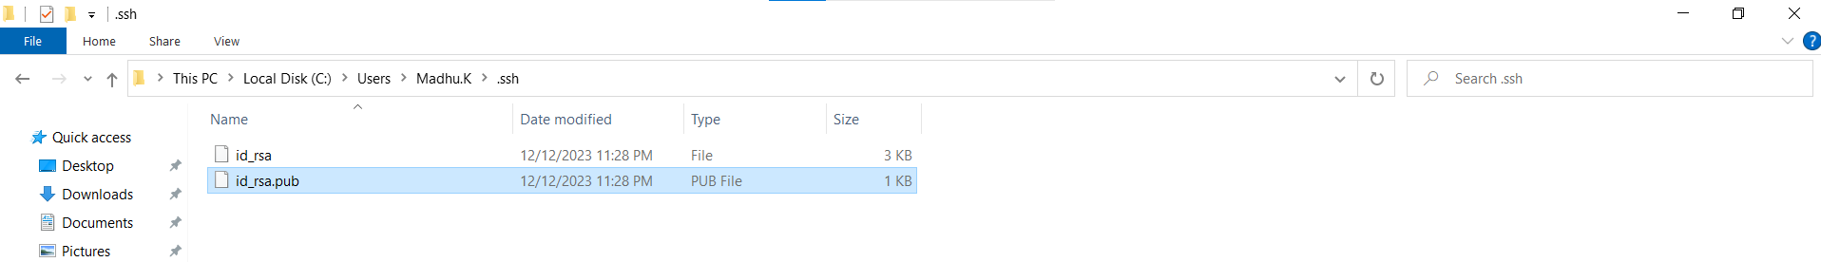

Open the file and copy the key like below

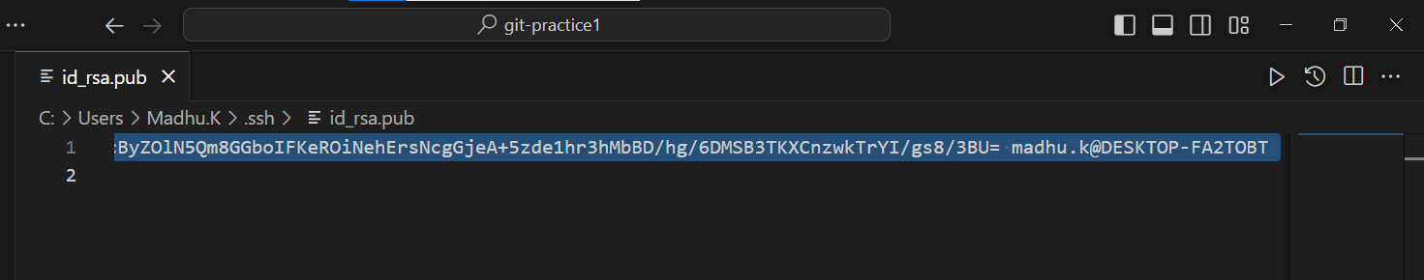

1. Go to settings in git hub click on SSH and GPH Keys after that click on New SSH Key

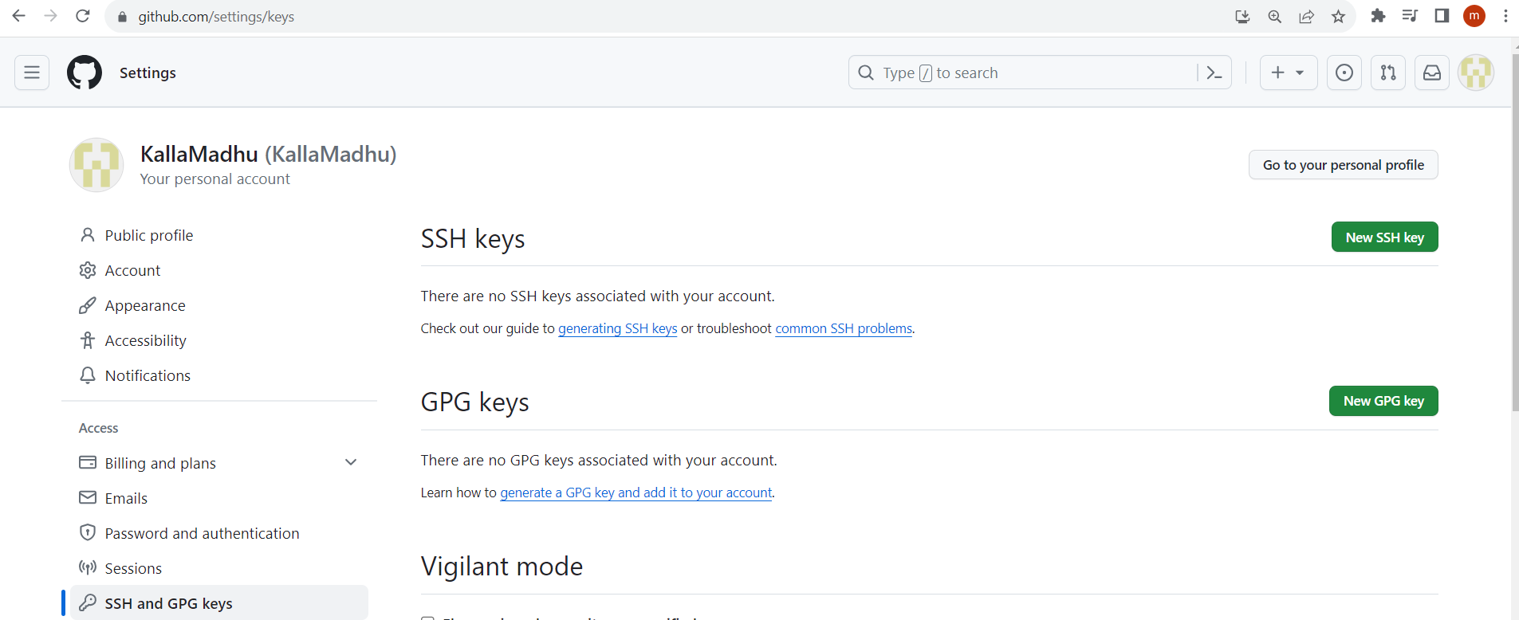

1. Now give a title and paste the copied key into the text area see below and click on add ssh key button.

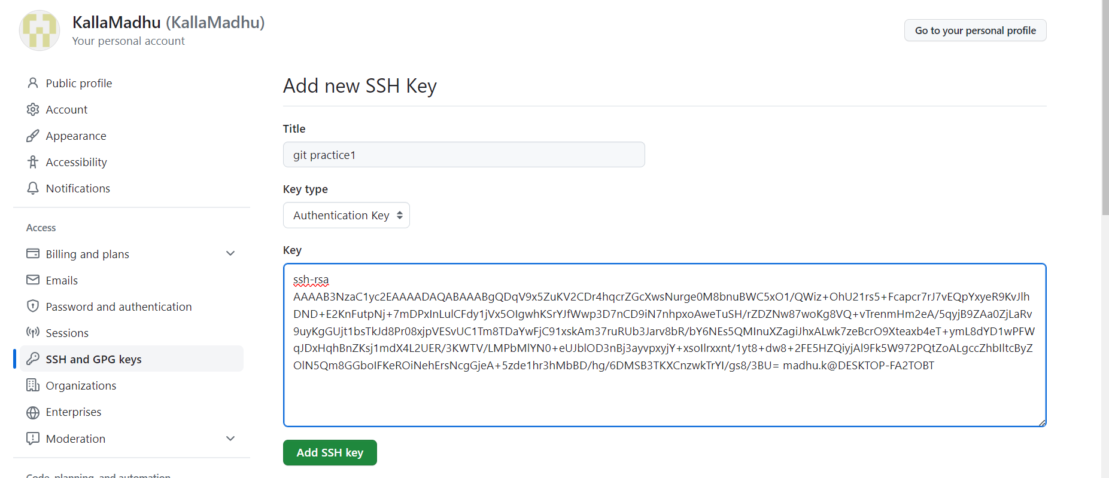

1. KYE ADDED SUCCESSFULLY

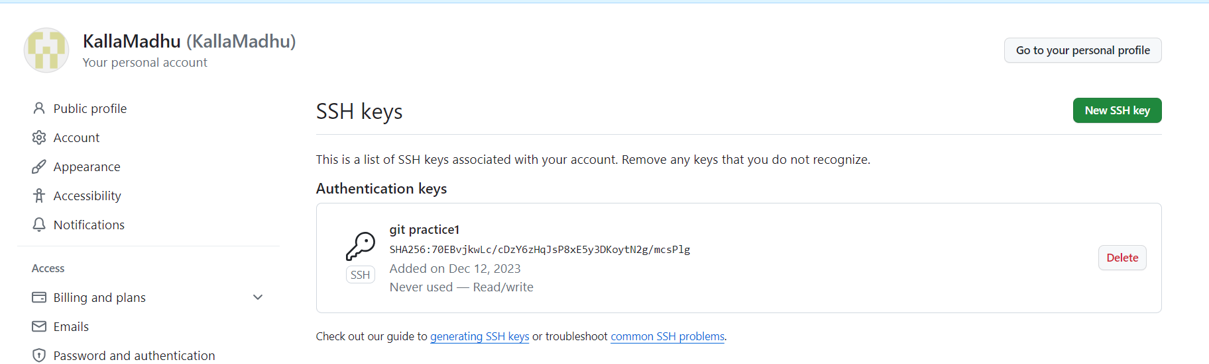

1. Now establish the connection “git remote add origin <https://github.com/KallaMadhu/git-practice1.git>” see the below image



1. **Now pushing the file from local to remote**

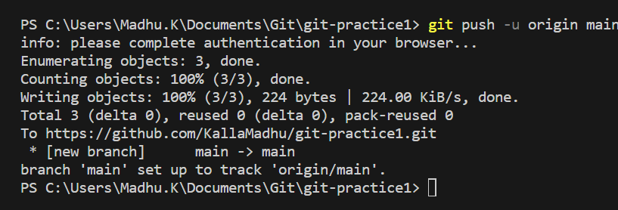

1. **Done**

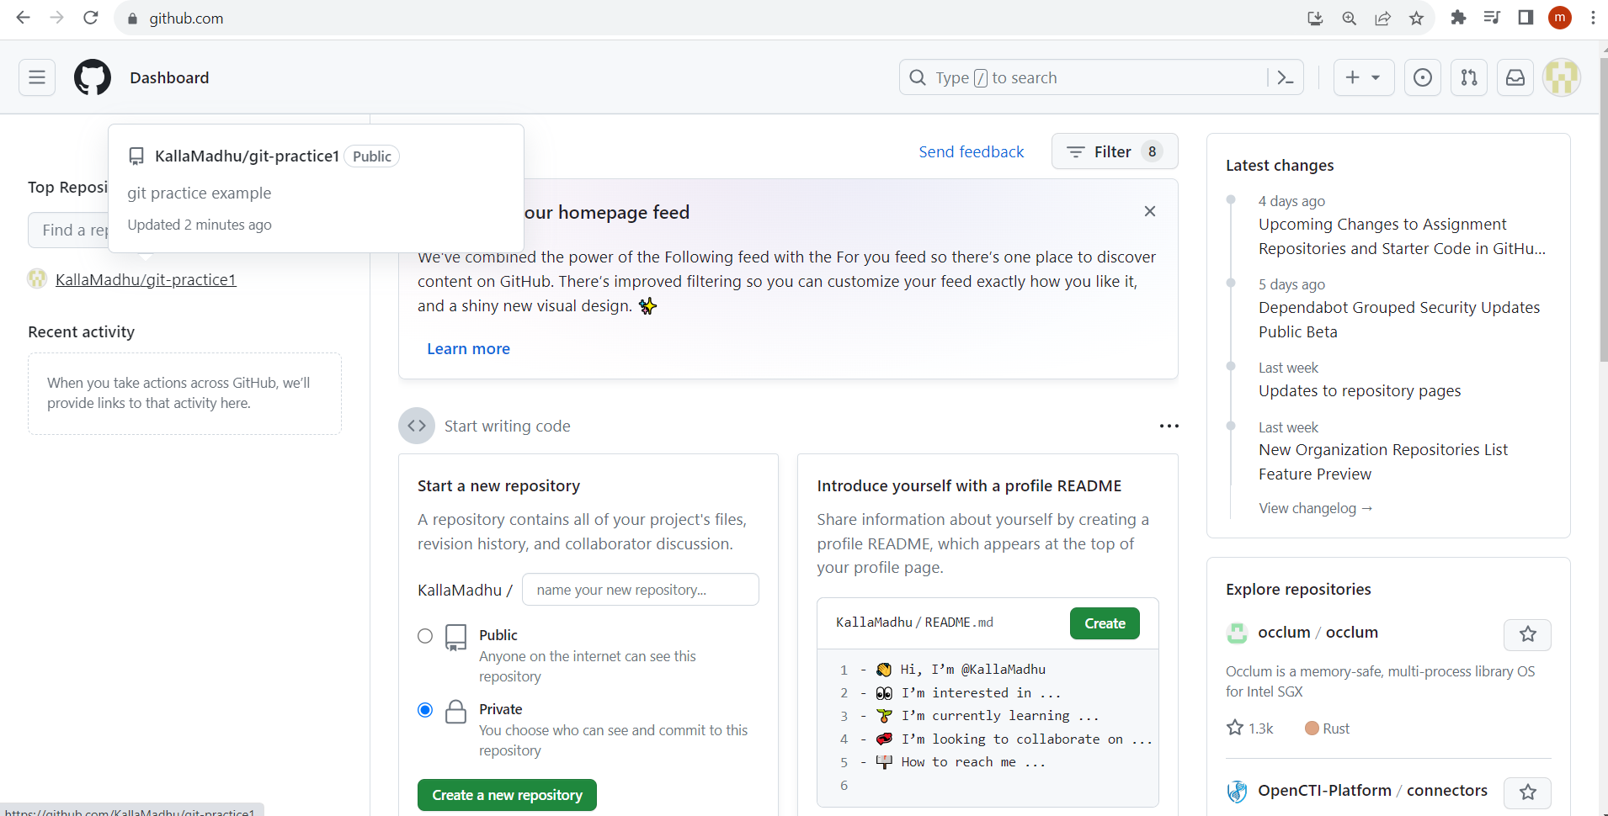

1. **Now I have written One.java**

class One

{

    static int add(int a,int b)

    {return a+b;}

    public static void main(String[] args) {

        System.out.println(add(100,200));

    }

}

**Sent to staging area**

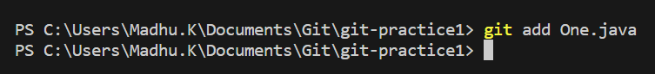

**Move file to git (local)**



**Move from local git to remote github(the below command git push origin main will do that)**

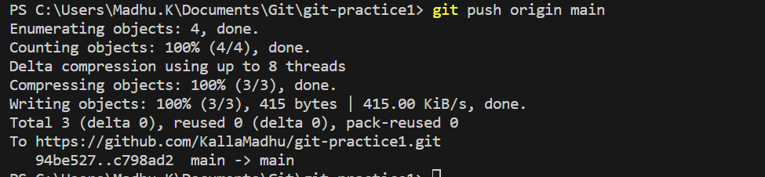

**Check in git hub(One .java is added)**

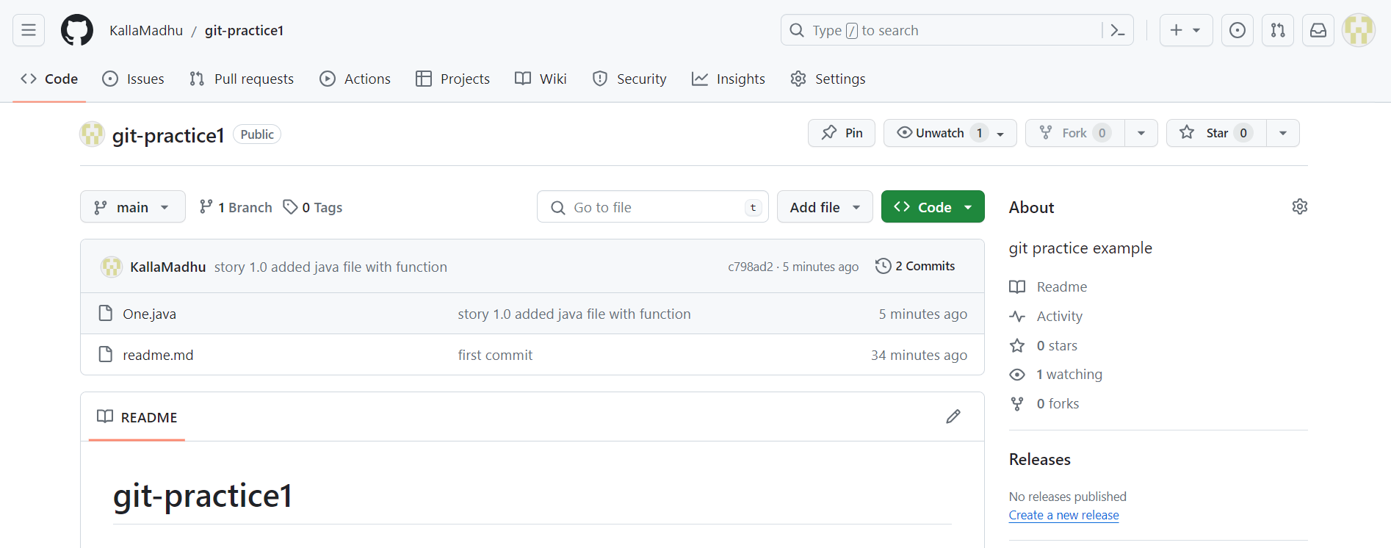

**Creating tags**

|  |
| --- |
| 1. Light weighted tag 2. Annotated tag |

**Annotated tag creation**



**Display tag**



**Display digital information**

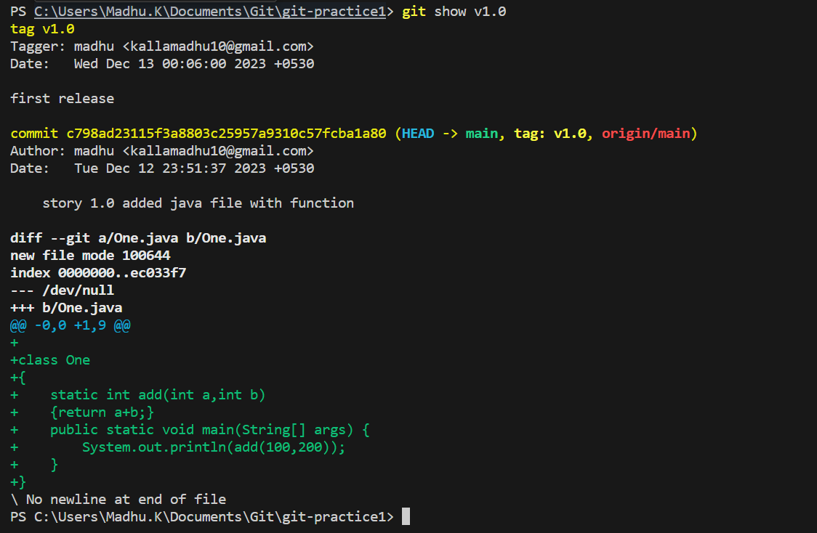

**Aftet adding tag I have modified file and pushed code to local git see the below image**

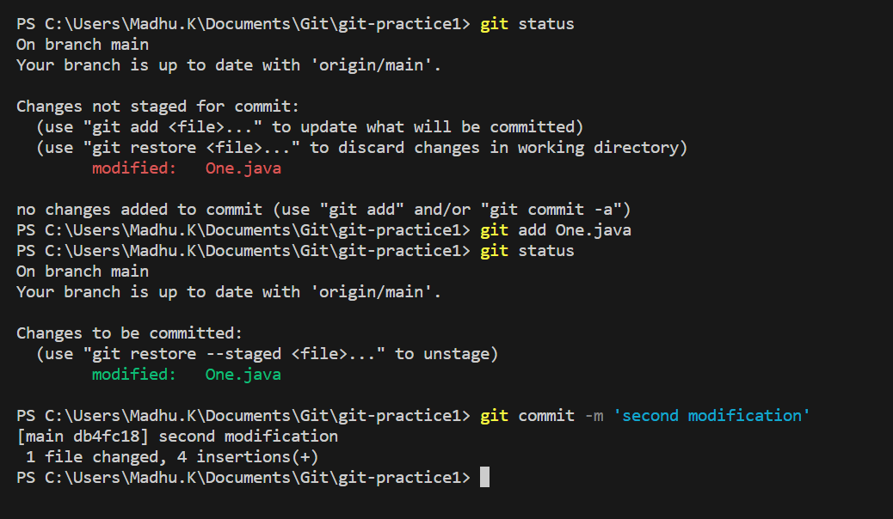

**We have pushed the modified code to github(remote repository)**

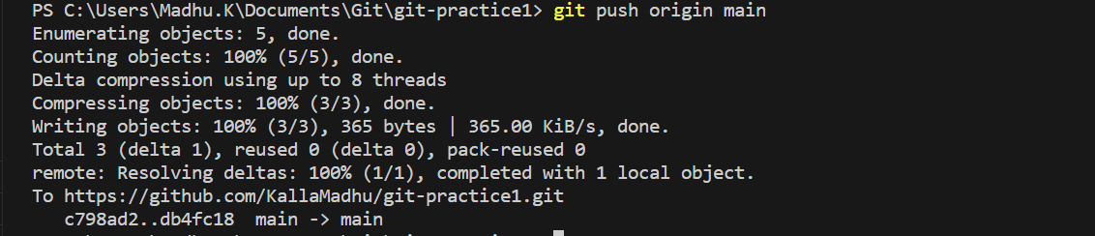

**We have commited and updated file is added but tags count is showing 0 only**

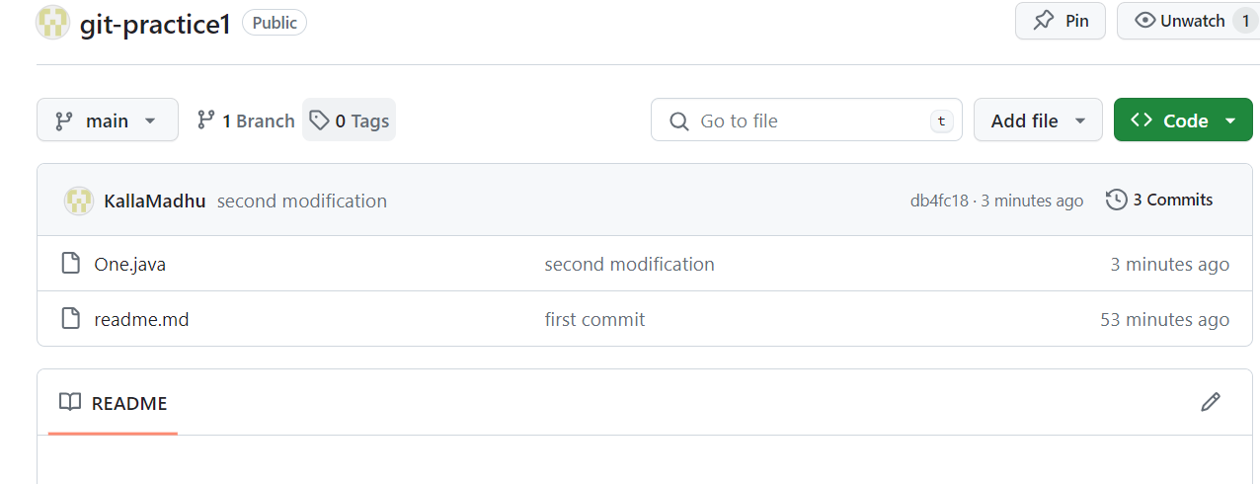

**I have created one more tag**

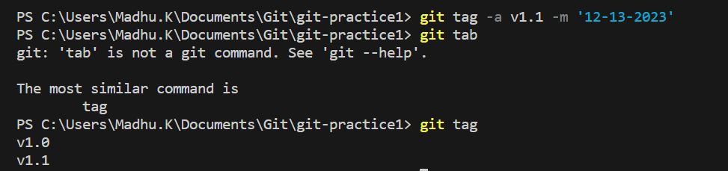

**Now command to push tags to git hub(remote repository)**

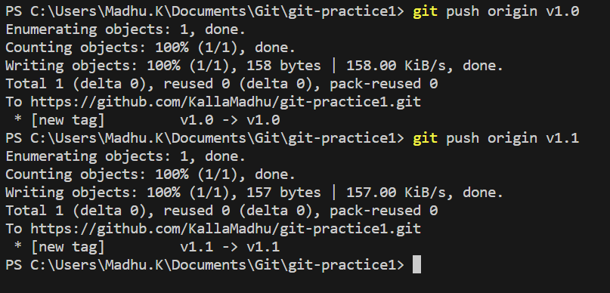

**Now the tags count is 2**

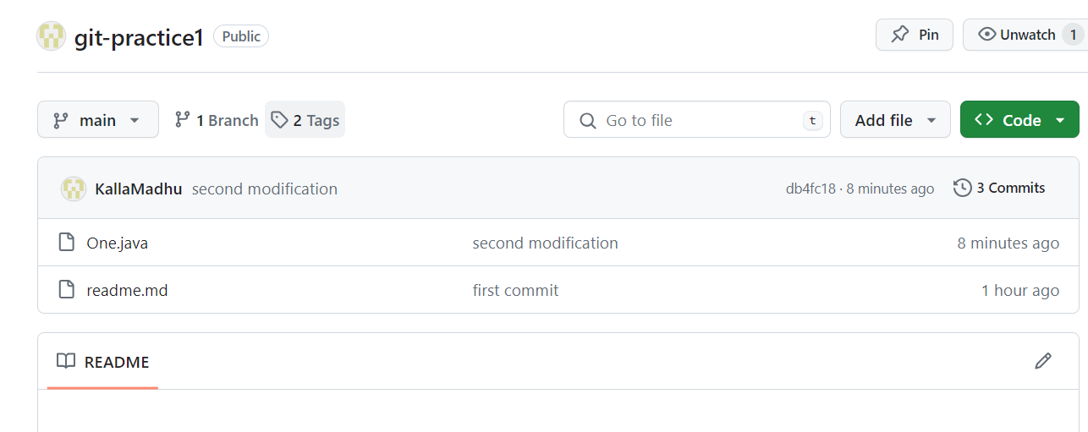

**If you click on tags link you can see both the tags. Now click those tags and check the code in it.**

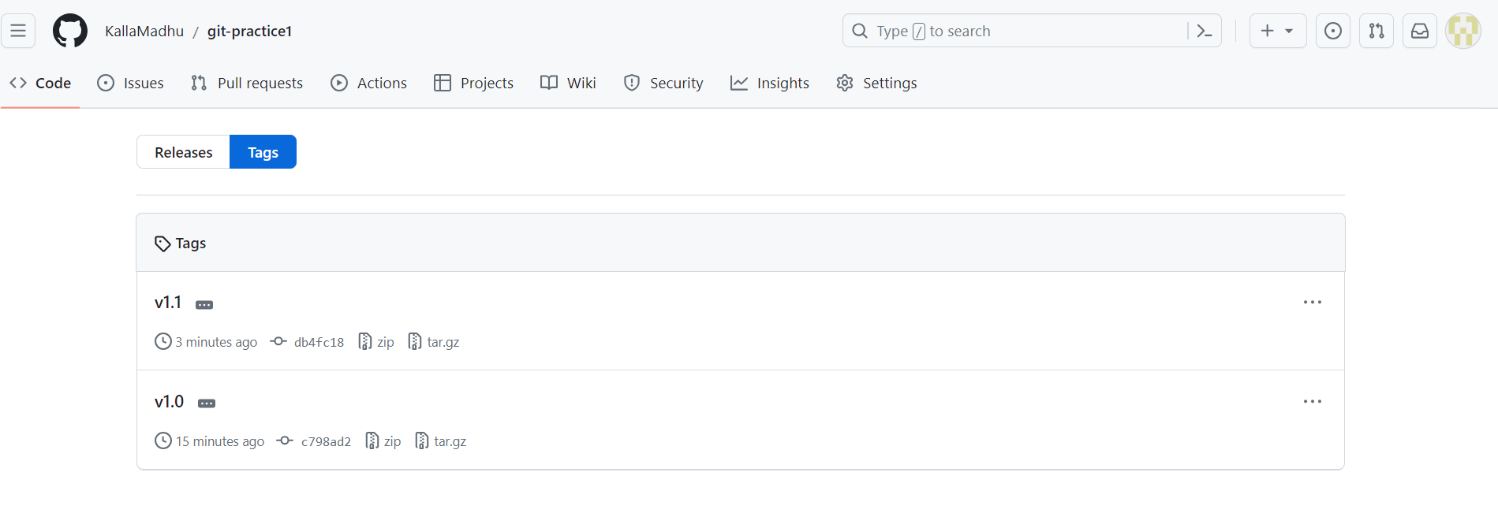

**How to create new branch?**

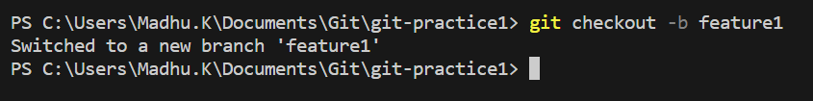

**Command to see the no.of branches existed in a git?**

In The below image the branch which is green color which has * is present feature.

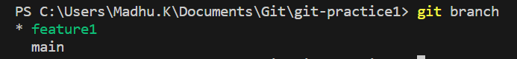

**Now whatever features we are adding to the existed code in vs code will be added automatically to the new fatures.**

**See the git status**

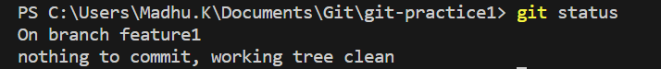

**Git status after modification**

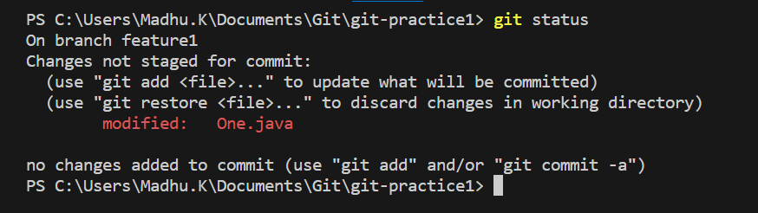

**Staging and commit is done**

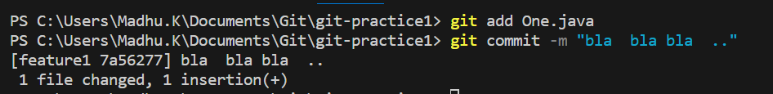

**To move from one branch to another branch we have two commands switch and checkout both are same.**

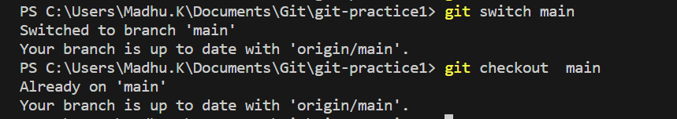

**Old code you can see in One.java when you switch from feature1 to main**

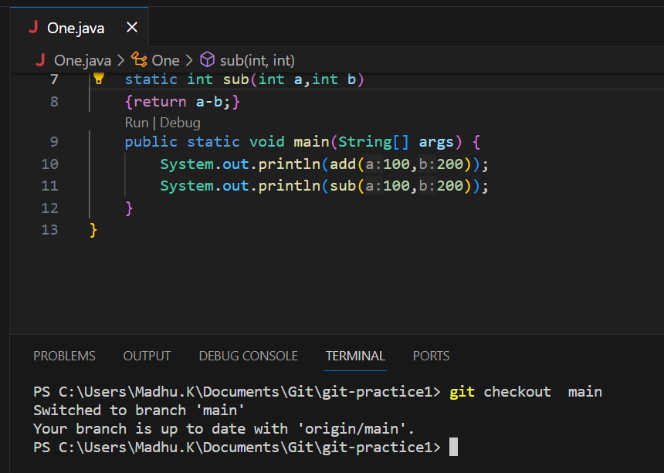

**See the code after switch from main to feature1**



**Creating another branch**



**To see the local branches (git branch)**

**To see the local and remote branches (git branch –all)**

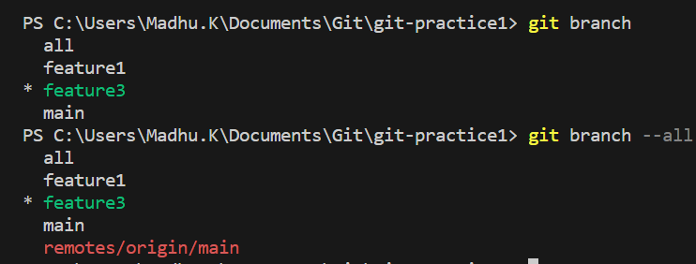

**How to move back to previous branch?**

Command: Git switch -

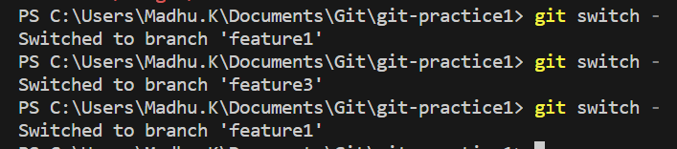

**Deleting branch**



**Added new features to feature1 branch**

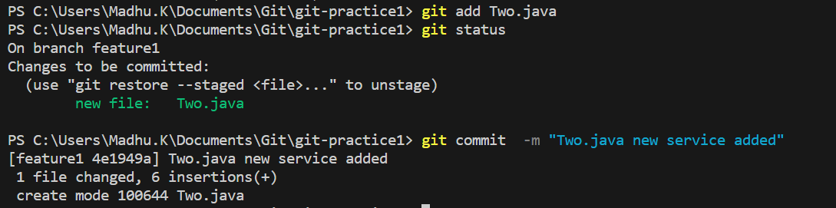

**Branch is added to remote server(git hub)**

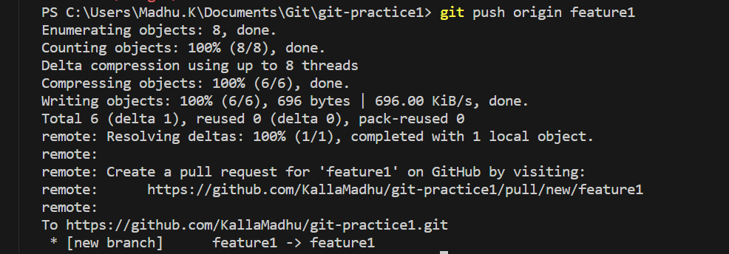

**Branches you can see in you github**

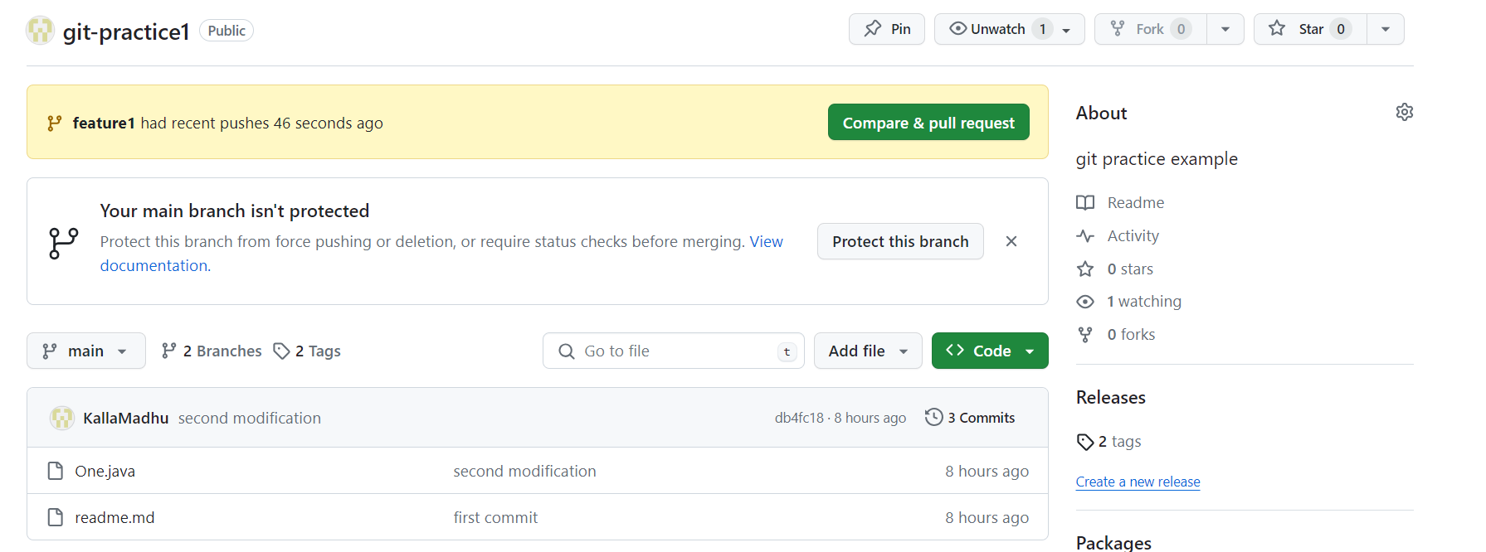

**I wanted to merge two branches i.e main and feature1**

Step-1: before merging pull the main branch and then you can add feature1 branch to main

Step-2: command pull the branch from github is

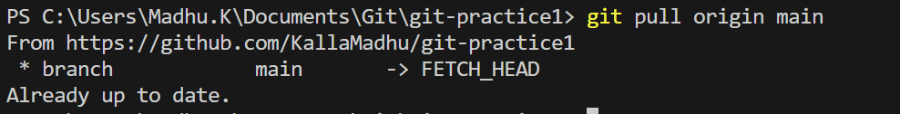

**After pull I have tried to merge branch feature1 with main but it is asking to commit the changes in local repository**

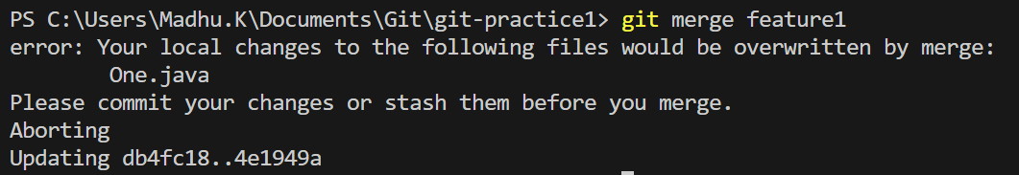

**Step-3: check in which branch you are**

**Step-4: Switch to main branch**

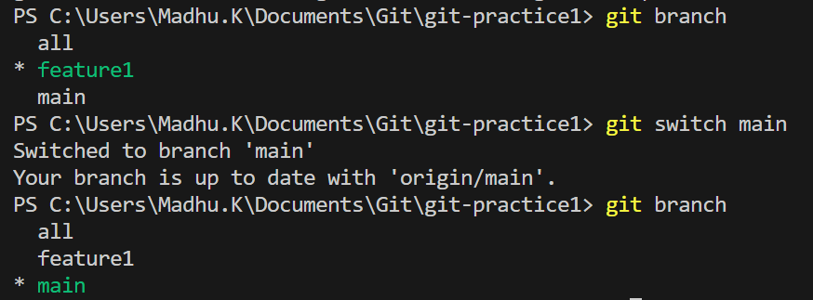

**Step-5:How to merge two branches?**

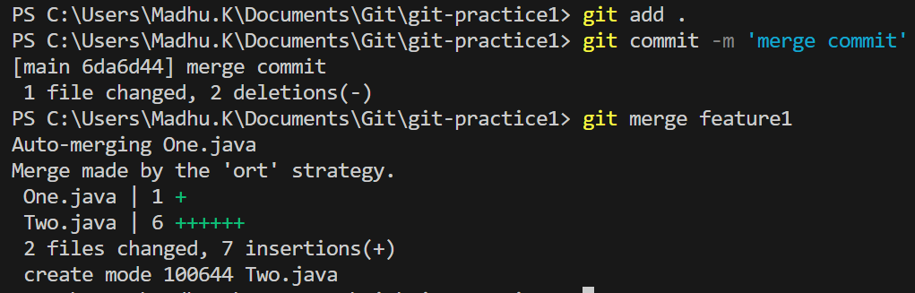

**Step-6: after merge you have to push main branch to hit hub.**

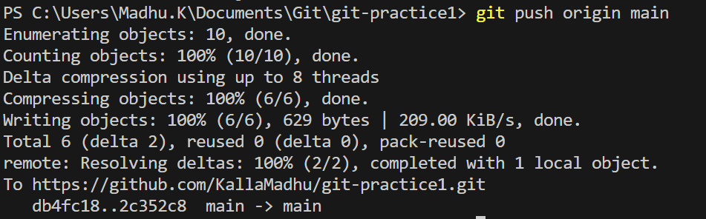

**Success: Updated Successfully**

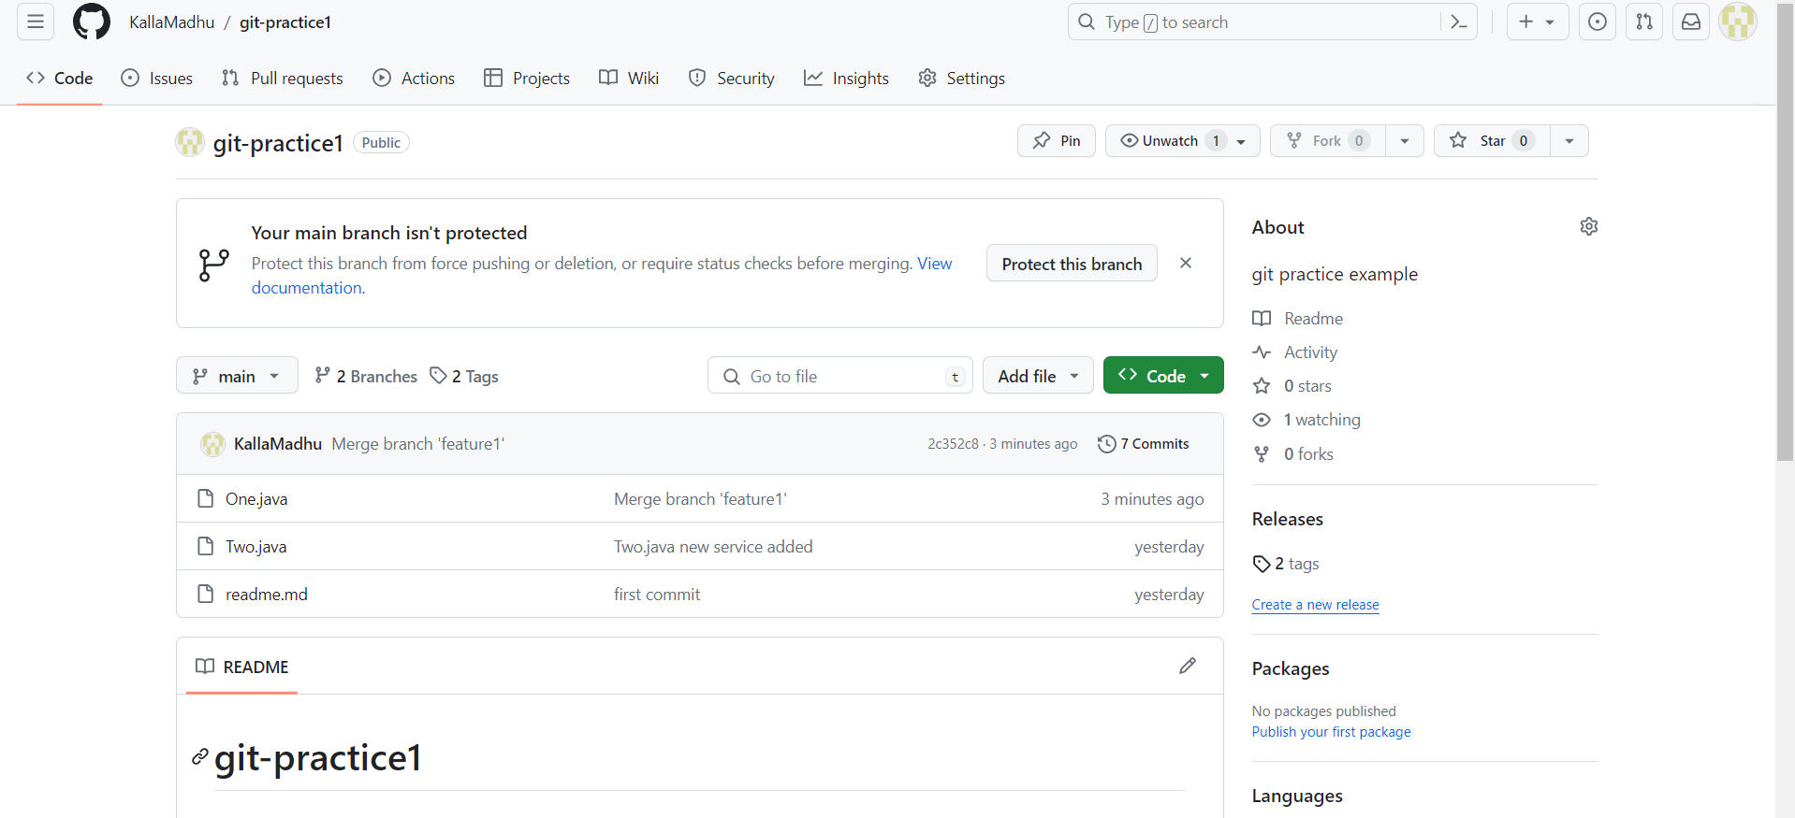

**11:00 am**

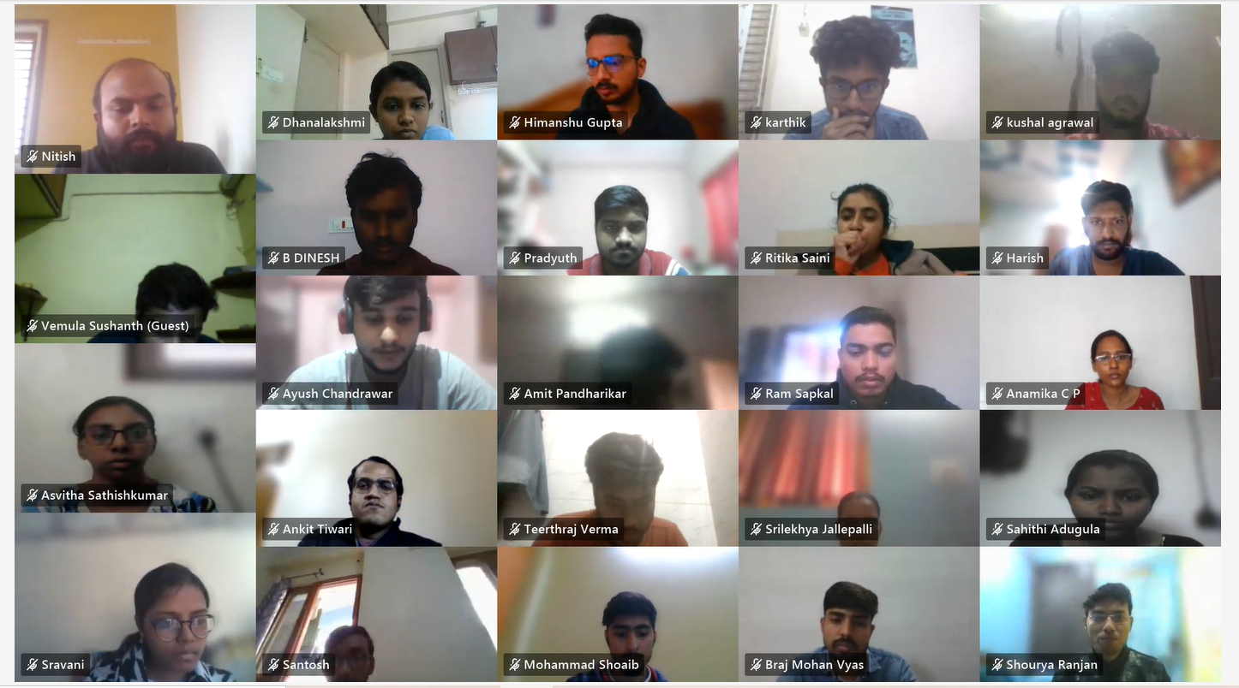

**11:01**

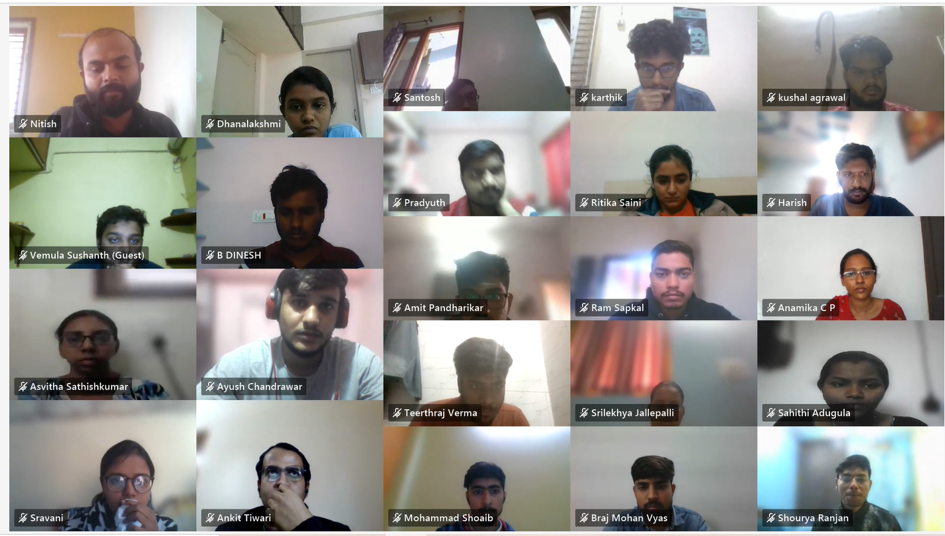

**How to push eclipse code to git hub**

**Step-1**

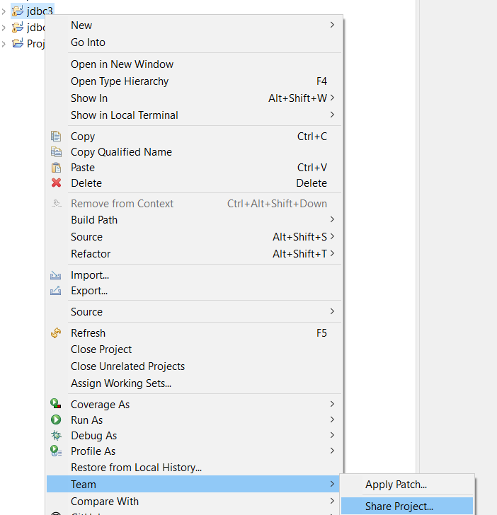

**Click on create new repository(click on Create button)**

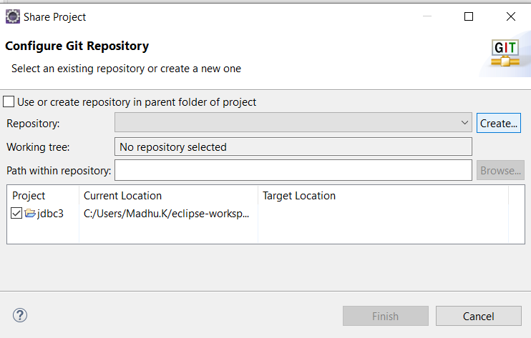

**Change repository name to repository2(your wish) and give branch name as main(replace master) and click on finish**

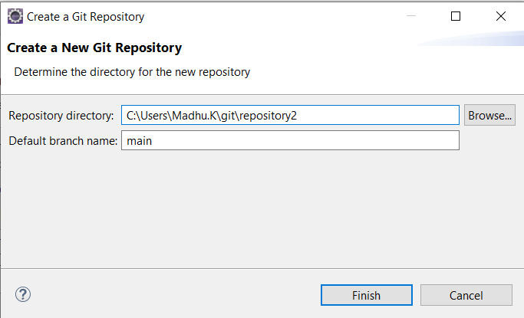

**Click on finish again see the below image**

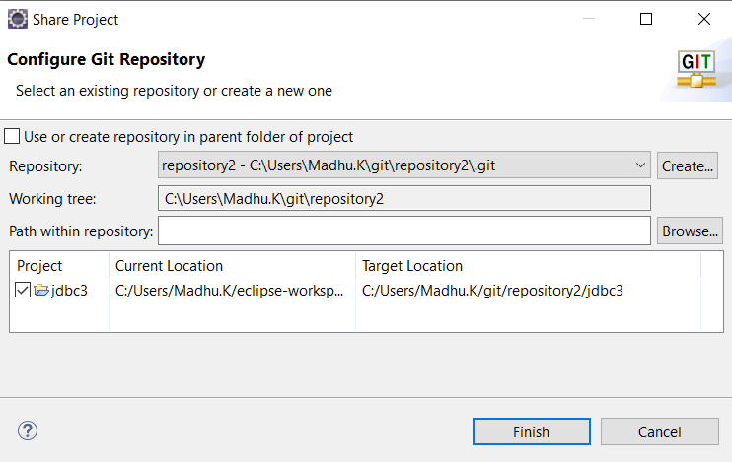

**Done(you have created repository)**

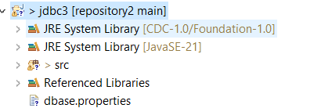

**Now move the files to staging and then commit them**

**Click on commit(see the below image)**

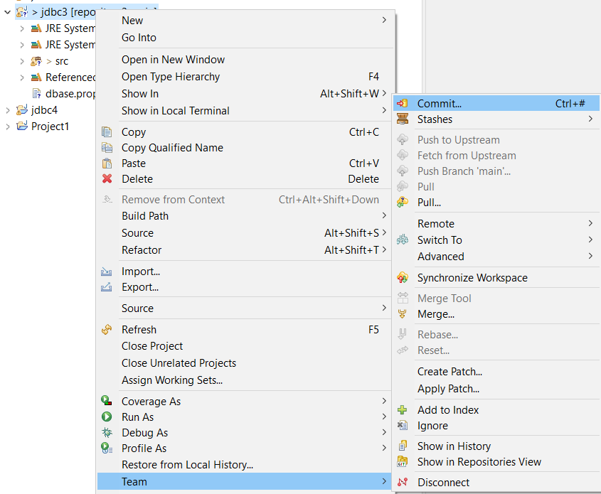

**When you click commit a new window will be opened like below**

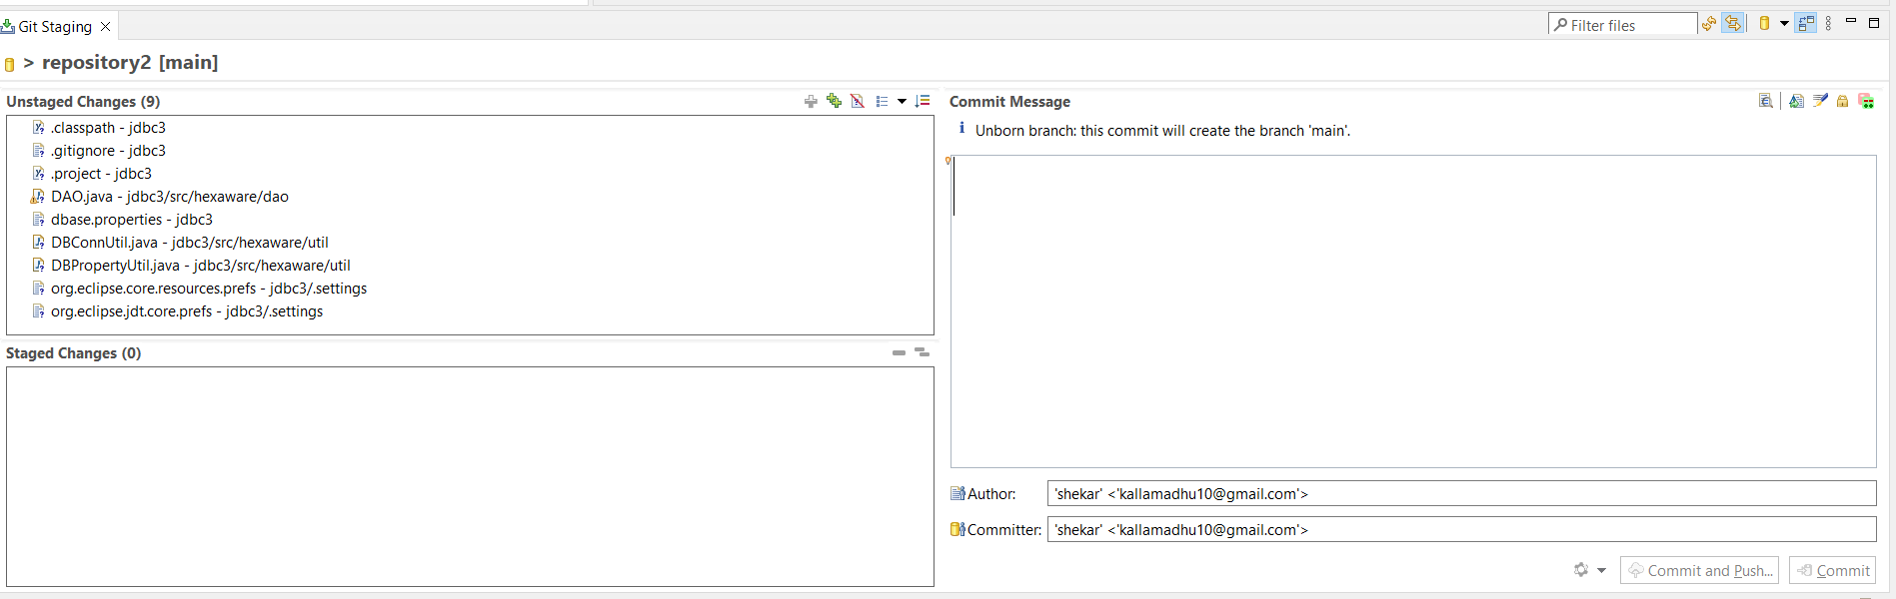

**Click on ++(green color) to move the files into staging area**

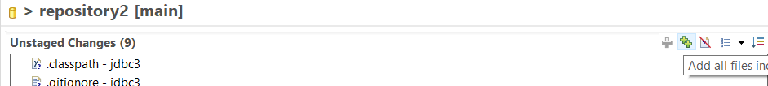

**Give commit comments and click on commit button in the bottom**

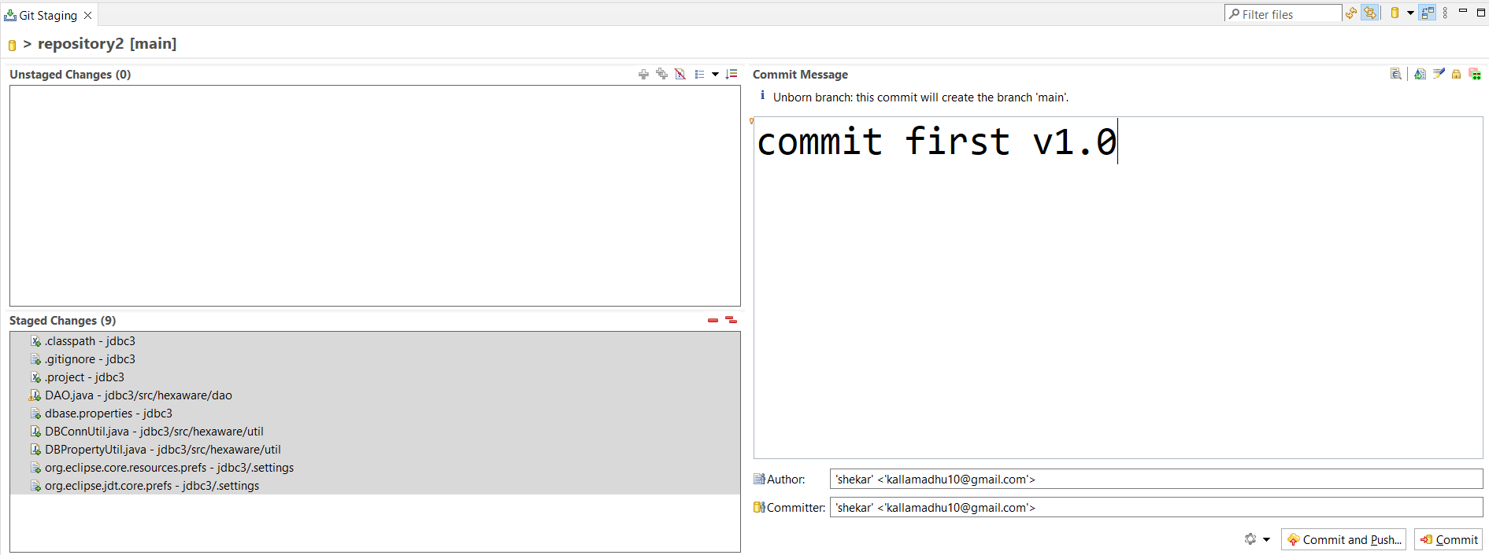

**Push branch main**

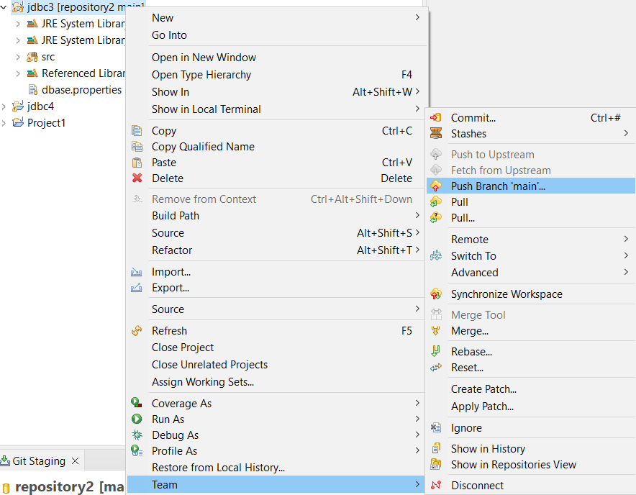

**Create new repository in git hub(click new button see the below image)**

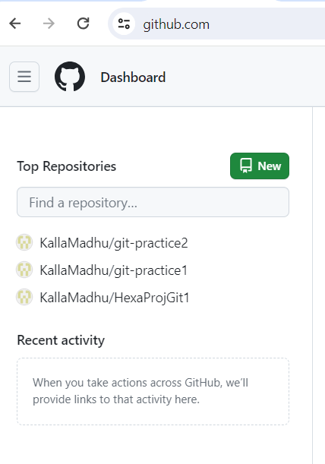

**Give repository name choose public and click on create repository button**

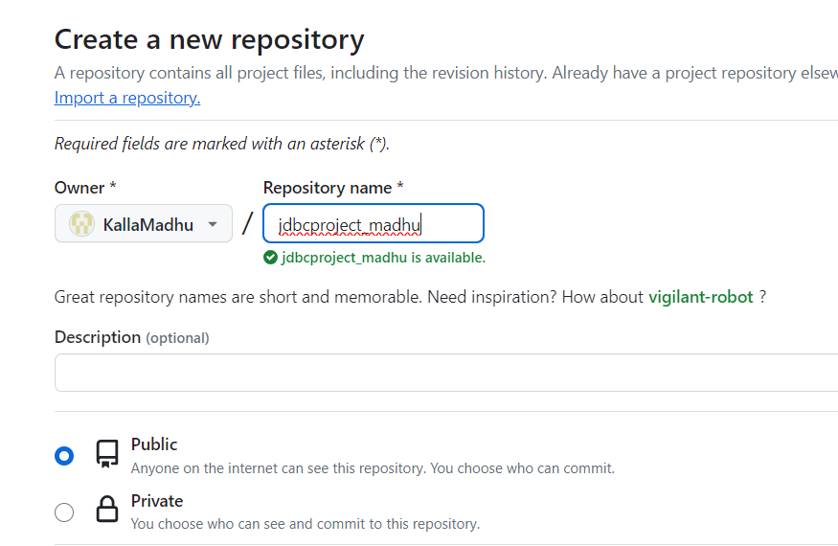

**Click on create repository button**

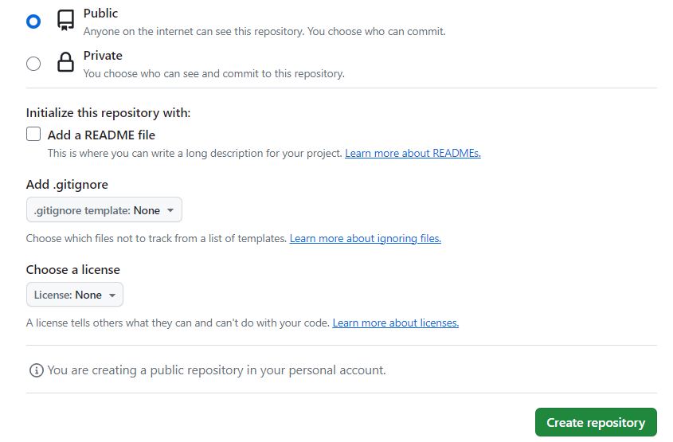

**Copy the repository url**

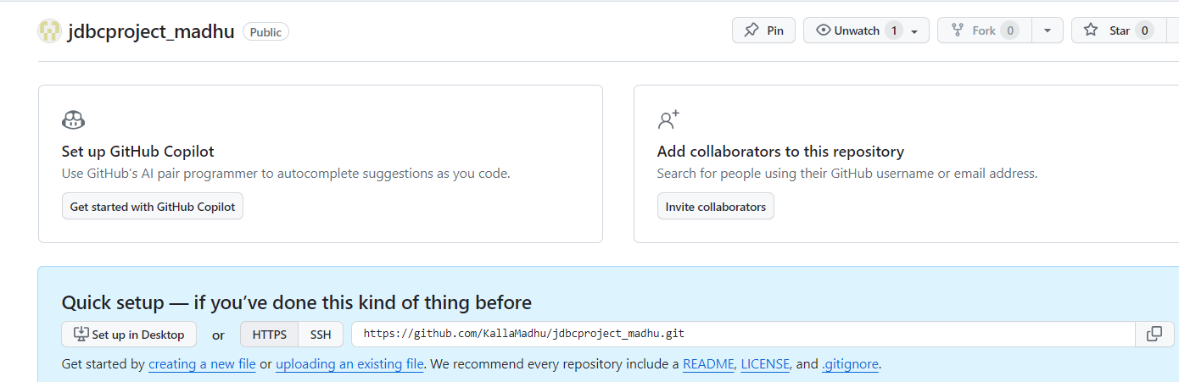

**Paste the url like below**

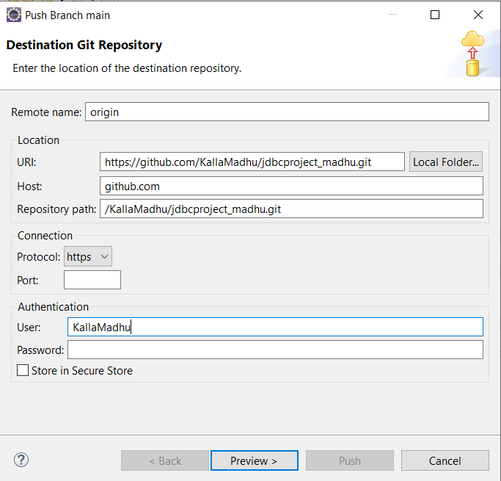

**Note: don’t use password but instead of password you have to create a token in git hub and use it here**

1. **Open the url** <https://github.com/settings/tokens>
2. **Generate token**

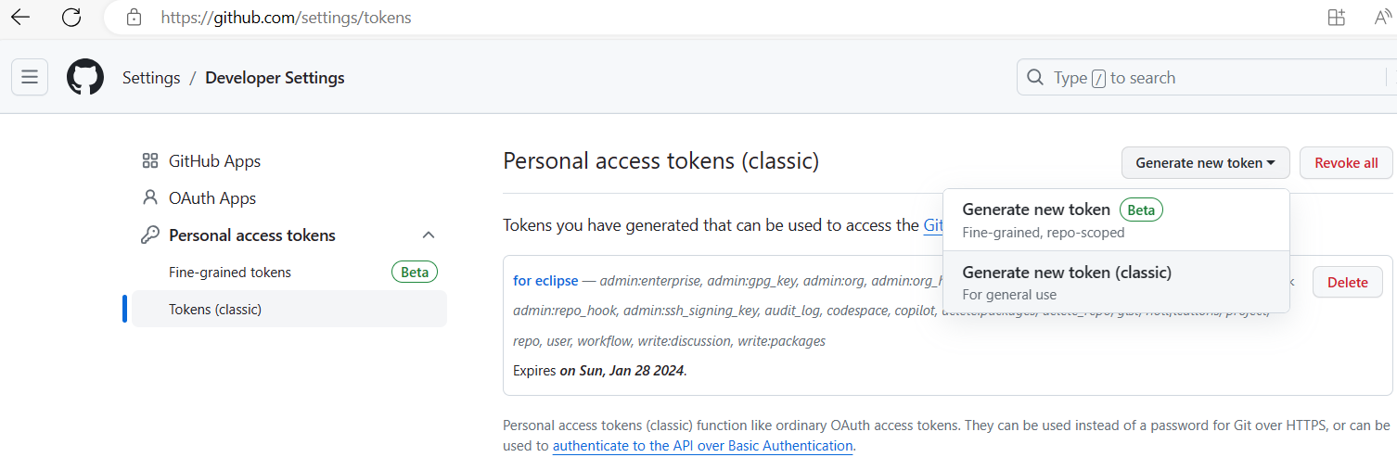

1. **Select all the check box and fill the note box(description) and click on GenerateToken button. Token will be create and like below**

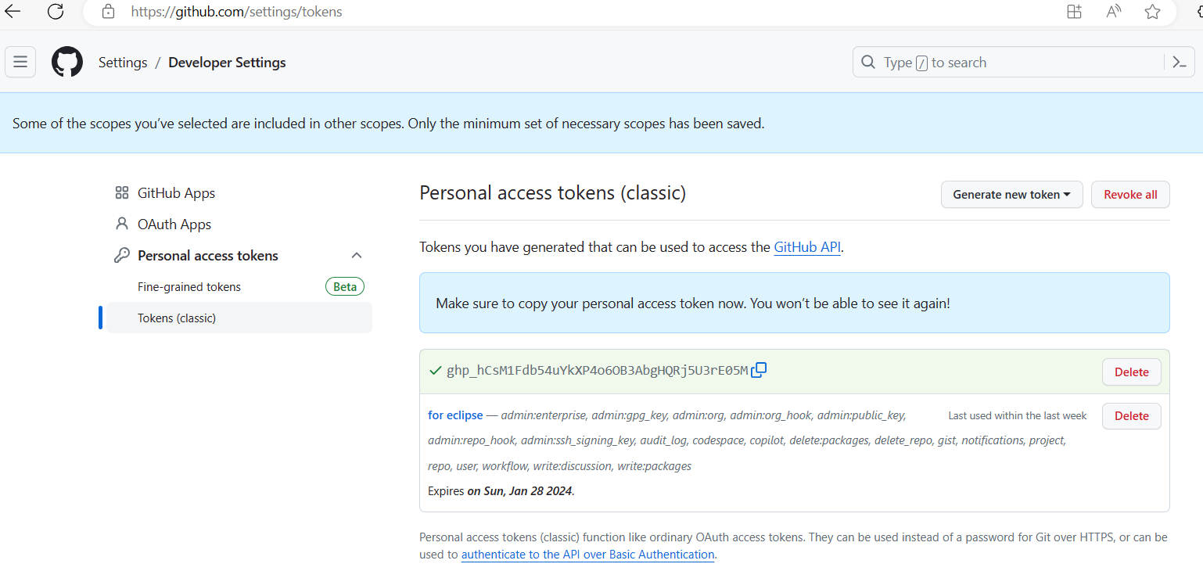

1. **copy the token and paste in the place of password in eclipse**

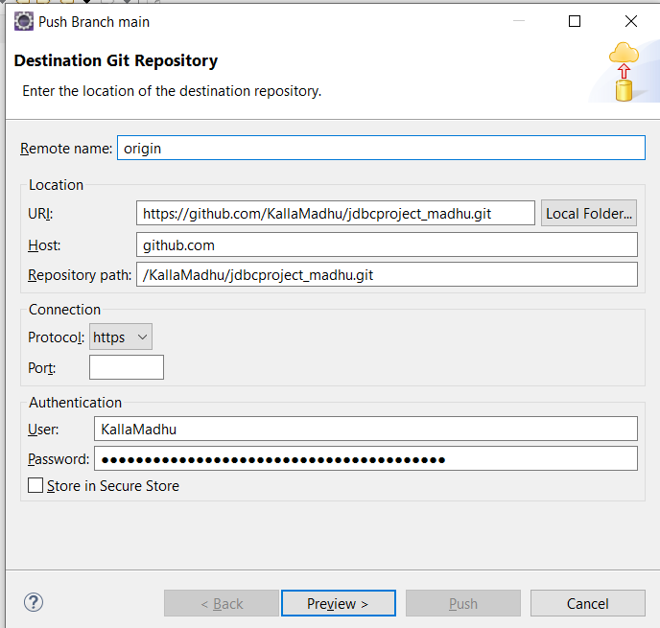

1. **click on Preview**
2. **click on Preview again**
3. **you can see this kind of window**

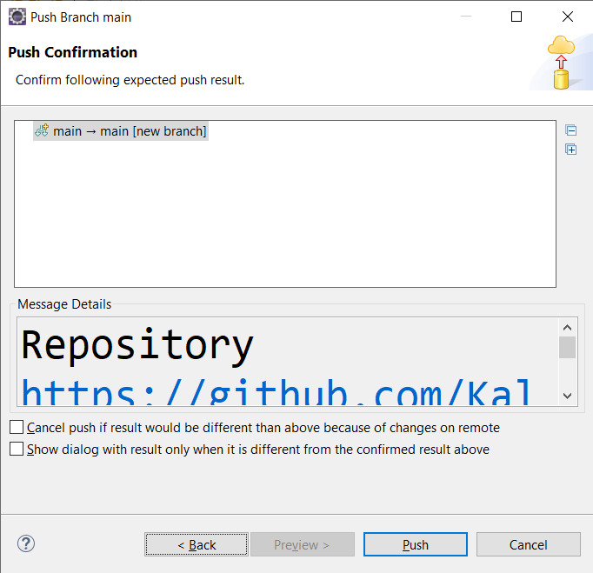

1. **click on push button again it will ask about username and password(token)**

**and then click on login**

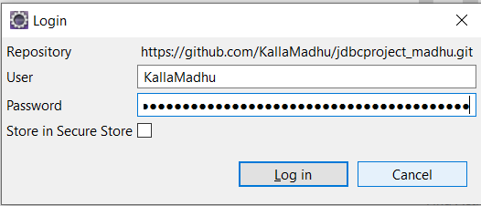

1. **pushed successfully**

